LAB 1 ASSIGNMENT

DISPLAYING AND DESCRIBING DISTRIBUTIONS

In this lab assignment you will use graphical and numerical tools in StatCrunch to explore the data about greenhouse gas (GHG) emissions reported from about a hundred of Alberta facilities in the ten year period 2004-2013. In particular, you will examine the distribution of GHG emissions in 2013, and analyse the trend and changes in the distribution of GHG emissions over the period. You will identify the largest emitters and compare some Alberta industrial sectors in terms of their total GHG emissions. The questions in the lab assignment refer to the StatCrunch tools discussed in Lab 1 Instructions.

Alberta Facility Greenhouse Gas Emissions

The global warming is driven mainly by the following greenhouse (GHG) gases: carbon dioxide (CO₂), methane (CH₄), nitrous oxide (N₂O), hydrofluorocarbons (HFC), perfluorocarbons (PFC) and sulphur hexafluoride (SF6). However, GHGs are not equal in their effect on the atmosphere. Each GHG has a unique average atmospheric lifetime and heat-trapping potential. GHG emissions are often calculated and reported in terms of how much CO₂ would be required to produce a similar warming effect over a given time horizon (usually 100 years). This is called the CO₂ equivalent (CO₂e) value and is calculated by multiplying the amount of the gas by its associated global warming potential. The idea is to express the impact of each different greenhouse gas in terms of the amount of CO2 that would create the same amount of warming.

Since 2004, the Government of Alberta has required industrial facilities across the province to report their GHG emissions annually through Alberta Specified Gas Reporting Program. Initially, the program had applied to all facilities that emit the equivalent of 100,000 tonnes (100 kilotonnes, or 100 kt) or more of GHGs in CO₂ per year. This threshold was lowered to 50 kt for the 2010 calendar year and subsequent reporting years. Note that the program just covers industrial sources; emissions from other sources including transportation, agriculture, commercial and residential are not included in the inventory. In 2013 reported industrial emissions accounted for 49.7 per cent of Alberta’s total emissions.

In this lab assignment you will examine the greenhouse gas data from up to 154 facilities in Alberta in the ten year period 2004- 2013. The data are posted under Open Government License- Alberta at
https://open.alberta.ca/dataset/specified-gas-reporting-regulation-summary.

The data are also available in the StatCrunch file lab1.txt located on the STAT 151 Laboratories web site at http://www.stat.ualberta.ca/statslabs/stat151/index.htm (click Stat 151 link, and Data for Lab 1). The following is a description of the variables in the data file:

Variable Name Description of Variable

YEAR Year in which the values of the emissions were obtained,
SECTOR Industry type,
LEGAL NAME Legal name of a corporation.
FACILITY Facility Name,
CO2 CO₂ emissions (in tonnes),
NH4 NH₄ emissions (in tonnes, CO₂ equivalent),
N2O N₂O emissions (in tonnes, CO₂ equivalent),
HFC HFC emissions (in tonnes, CO₂ equivalent),
PFC PFC emissions (in tonnes, CO₂ equivalent),
SF6 SF₆ emissions (in tonnes, CO₂ equivalent),
TOTAL Total CO₂ equivalent emissions (in tonnes).

- First you will examine the data collection process.

- What assumptions must be made about the data collection process to ensure that valid conclusions about the trends in emissions can be reached based on the data? What are the limitations of the data?

In order to reach valid conclusions about the data, each facility must use the most appropriate and common for their particular industry GHG estimation methodology. The methodology should be consistent over the reporting period to allow meaningful comparisons of emissions from one year to another. Control equipment must be functioning properly and its accuracy and reliability be systematically assessed. Moreover, strict verification protocols and estimations by independent third- party verifiers must be in used to validate the data and make compliance determinations.

As the methods to estimate GHG emissions are constantly being refined within each industry, the data may be limited by the lack of consistency and also variation in the annual facility list (facilities may exceed or fall below the reporting threshold in subsequent years). Also facilities reporting voluntarily introduce some bias in the data.

- The number of facilities reporting their annual emissions varies from year to year. What are possible direct reasons for the variability? How this may affect the conclusions about the data?

Changes in production levels, processes and technologies, the types of fuels used at a facility can all result in a change in the annual emissions reported, so that a facility may fall below or attain the reporting threshold of 50 kt CO2e from one year to the next. The number of voluntary reporters may also change each year, which can also affect the number of reporting facilities.

The fact that emissions from different facilities may be included in the inventory year after year makes it harder to compare the total CO2e emissions if the number of those facilities is large. However, the emissions from those facilities are close to the threshold value of 50 kt and unlikely to distort the data in a significant way.

- Some facilities that do not exceed the threshold of 50,000 tonnes (50 kt) are voluntary participants in the program and are included in the inventory. Discuss how the voluntary-reported greenhouse gas emissions may affect conclusions for the data.

Those voluntary participants provide more accurate picture of the sources and amounts of emissions from Alberta facilities because the more facilities are voluntarily reporting their emissions, the better estimate of the total emissions in the province can be obtained.

On the other hand those voluntary participants may affect the summaries for the data, in particular lower the mean and median of total emissions. Note that some manufacturing or industrial operations that use many scattered facilities over the province, each with the total annual emissions just below the threshold of 50 kt will likely be excluded from the inventory.

- In the period 2004-2009 the mandatory threshold for reporting emissions was 100 kt. This threshold was lowered to 50 kt for the 2010 calendar year and subsequent reporting years. How this change may affect any comparisons in total emissions for years before and after the threshold change?

The decrease in the threshold level from 100 kt to 50 kt has increased the number of reporting facilities in the subsequent years. The number of facilities reported prior to the change varied between 93 in 2009 and 109 in 2008. This makes it harder to compare the trends in the total emissions between 2004-2009 and 2010-2013.
- Now you will examine the reported Alberta greenhouse gas emissions for 2013.

- How many facilities reported GHG emissions in 2013 and what were their total CO2e emissions? What are the mean, standard deviation, and maximum value of the total CO2e emissions? What are the three quartiles?

The requested summaries are provided in the output below:

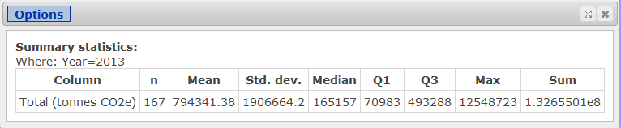

For the 2013 calendar year, 167 facilities in Alberta reported greenhouse gas emissions. The total reported GHG emissions (CO2 equivalent) for these facilities equalled 132.7 megatonnes (Mt). (1 MT=1 million tonnes or 1,000 kilotonnes). This number includes facilities that were below the 50 kt threshold, but voluntarily reported.

The average total CO2e emissions were 794341.38 tonnes (7.94 Mt) with standard deviation of 1906664.2 tonnes (1.91 Mt). The median is 165157 tonnes (much smaller than the mean). The first and the third quartiles are 70983 and 493288 tonnes, respectively.

- How many facilities reported their emissions voluntarily in 2013? What is the contribution of total reported greenhouse gas emissions by facilities reporting their emissions voluntarily in 2013?

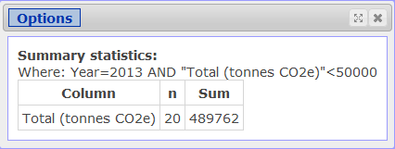

Twenty facilities reported their emissions voluntarily (total CO2e emissions below 50 kt threshold) with the total of 489762 tonnes. The percentage contribution of the facilities with the total emissions not exceeding the threshold of 50 kt is 489762/132655010=0.003692 which is less than 0.4%. The relatively very small percentage of emissions from the voluntary facilities does not change much the above summaries for all 167 facilities. See the output below (not required).

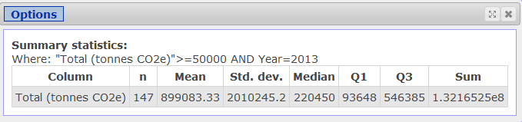

- Which facility in Alberta had the largest total CO2e emissions in 2013? What were its total emissions in that year? Compare the total emissions from the single facility with the total emissions of 110 lowest CO2e emitters for that year (their emissions are below 300,000).

The largest annual total CO2e emissions in 2013 from a single facility were 12.548723 Mt. The value comes from Syncrude’s oil sands facility at Mildred Lake and Aurora North Plant Sites (Wood Bufallo). The total CO2e emissions from the single facility matched approximately the emissions produced by 110 reporting facilities at the bottom (or 90 facilities at the bottom with the annual emissions exceeding the 50kt threshold).

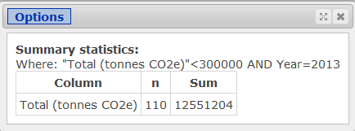

- What is the 95th percentile of the total CO2e emissions and what is the percentage contribution of the remaining 5% of the facilities in the total CO2e emissions? Report the appropriate values from the output. There is no need to paste the outputs into your report.

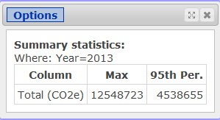

The 95th percentile is 4538655 tonnes (95% of all 167 facilities have CO2e emissions at or below the number). The remaining 5% of facilities at the top (8) contribute 63869636 tonnes which constitutes almost 50% of all CO2e reported emissions in Alberta (exact value is 48.1472%).

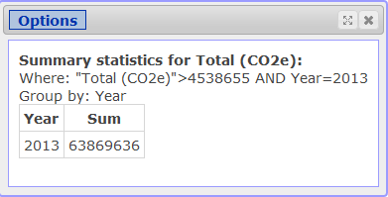

- What were the total CO2e emissions for each of the 16 sectors in that year? Which sector reported the largest share of 2013 greenhouse gases in Alberta and what was its share? Paste the appropriate output into your report. Obtain also a pie chart to display the contribution of each sector in total 2013 reported emissions. Paste the chart into your report.

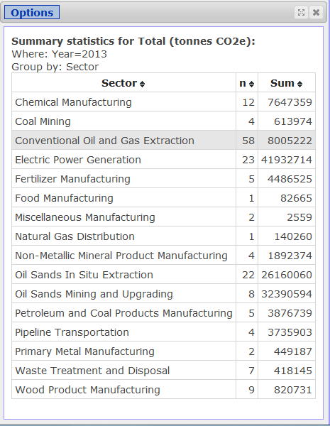

The contribution of total reported greenhouse gas emissions by industrial sector is shown in above figure. Based on the output, the total oil sands operations (oil sands in situ extraction combined with mining and upgrading), reported the largest total CO2e emissions of GHG gases in Alberta. The emissions from the sector were above 58.5 Mt, almost half of all emissions reported in that year. The electric power generation was the second largest source of GHG emissions with its emissions reaching almost 42 Mt. The conventional oil and gas extraction was in the third place in their contribution to total greenhouse gas emissions by industrial sector.

The following StatCrunch tool was used to obtain the pie chart:

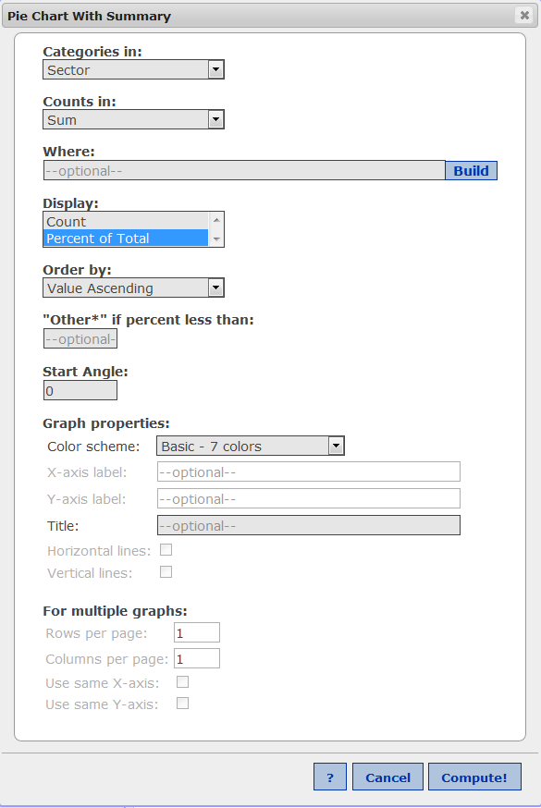

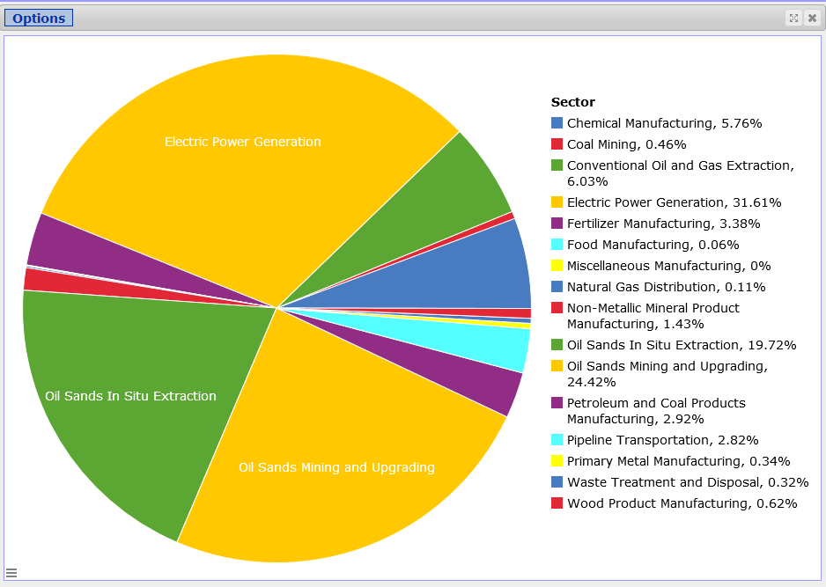

- What was the contribution of each gas type in total reported greenhouse gas emissions? In order to answer the question, obtain the total emissions for each gas type and a pie chart displaying the contribution of total reported GHG emissions by gas type and comment briefly.

Approximately ninety-five per cent of the total reported Alberta greenhouse gas emissions were in the form of carbon dioxide. The remainder was in the form of methane, nitrous oxide and hydrofluorocarbons. More precisely, CH4 (4.31 per cent or 5.7 Mt CO2 e), N2O (0.85 per cent or 1.1 Mt CO2 e), HFCs (about 0.01 per cent or 8.6 kt CO2 e), P FCs (<0.001 per cent or 0.09 kt CO2 e) and SF6(<0.01 per cent or 1.7 kt CO2 e). The contribution of total reported greenhouse gas emissions by gas type is depicted in the pie chart above.

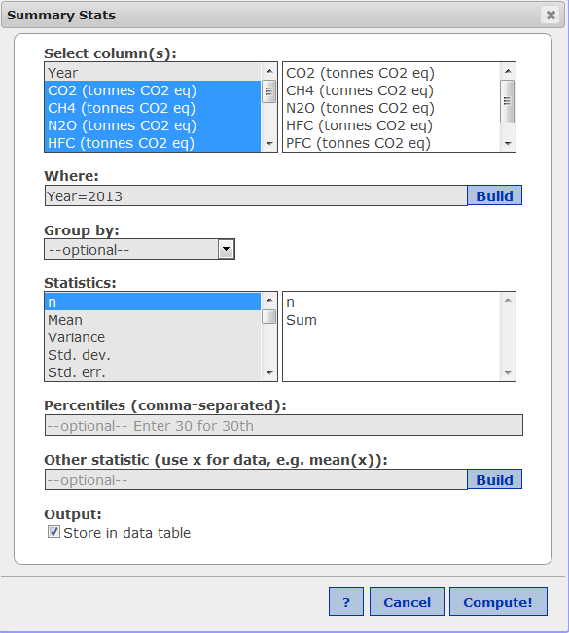

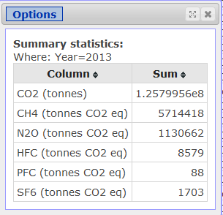

The summary can also be obtained in the data table:
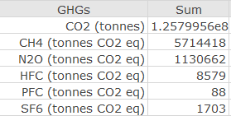

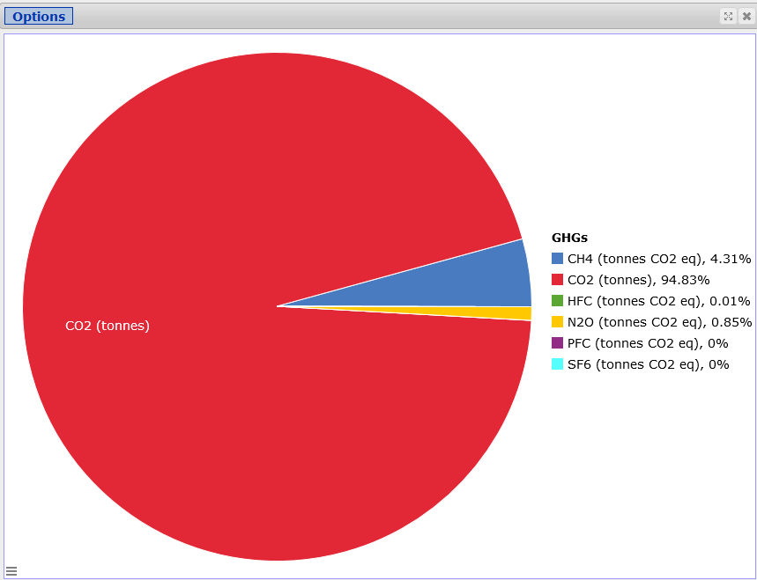

- Obtain the frequency histogram of total CO2e emissions in 2013 with bins starting at 0 and width of 1,000000. The format of your histogram should be the same as the format of the histogram in
Lab1Instructions (title and labels at the axes). Describe the shape of the histogram? What do you conclude about the distribution of total CO2e in Alberta in 2013?

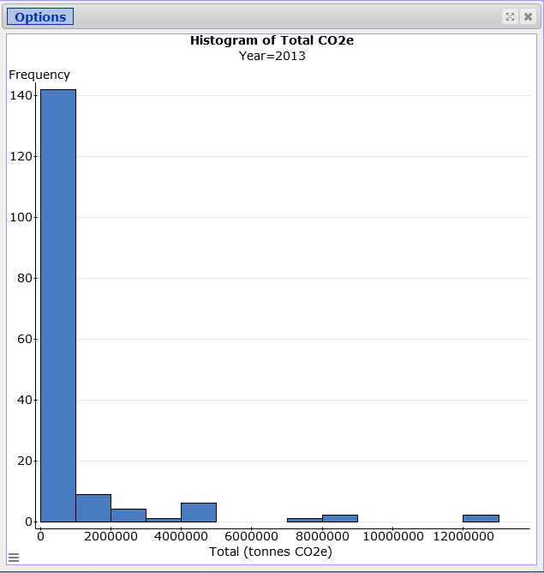

The histogram of CO2e emissions in 2013 is single-peaked and heavily skewed to the right. Over 140 out of 167 facilities produced emissions below 1Mt (1 million tonnes). There are several facilities with the total CO2e emissions exceeding 4 Mt. There are two facilities with the total emissions exceeding 12 Mt.

- Now you will explore trends in reported greenhouse gas emissions in Alberta. In order to meaningfully compare the data over time, emissions from facilities reporting their emissions voluntarily must be excluded. Therefore for the comparisons over the entire period 2004-2013 only facilities whose emissions are 100 kt CO2e or more will be considered.

- Obtain the total emissions for all facilities with total emissions of 100 kt or more for each year of the period 2004-2013. Check “Store in data table” option. Paste the summaries into your report. Calculate the percentage increase in total emissions in the period based on the summaries. Obtain a time plot for the summaries. Paste the plot into your report.

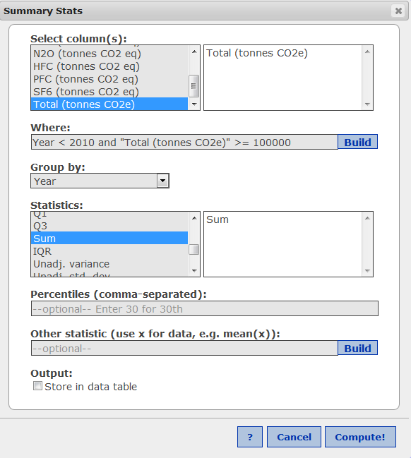

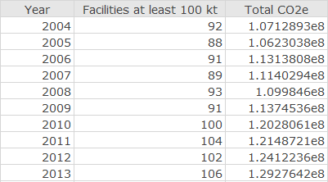

- The plot is shown below:

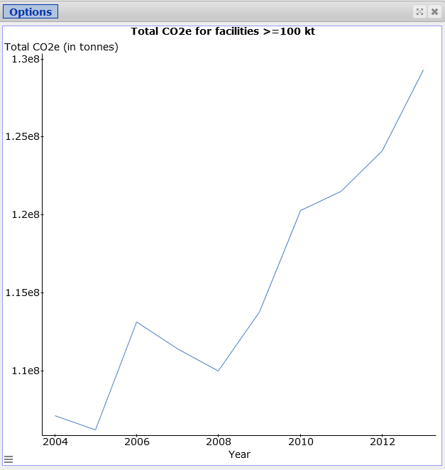

Overall, there is a steep increase in total CO2e emissions over the period. The total emissions fall in 2006-2008. The rate of increase seems to be larger in the period 2008-2013. Over the ten year period the total emissions increase by 20.68% (1.2928-1.0713)/1.0713).

- Obtain side-by-side boxplots of Total CO2e by Year for all facilities with total emissions of 100 kt or more for each year of the period 2004-2013. Check the “Use fences to identify outliers” option. Paste the boxplots into your report. Compare the centres, spreads and shapes of the ten distributions. Identify the largest emitters over the period (hover the cursor over the outliers). If the same facility appears more than once as the largest emitter in the period, assess progress in reducing emissions in the facility over time.

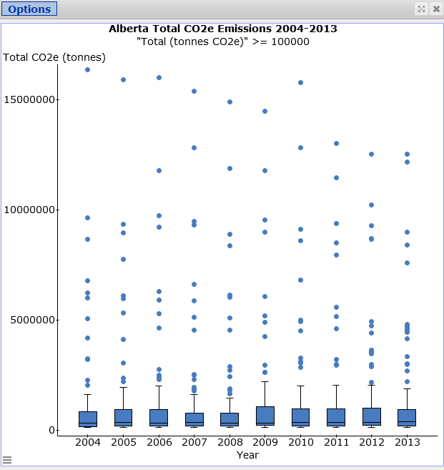

The distribution of total CO2e for each year in the period 2004-2013 is highly skewed to the right with several outliers each. The median values are very similar over the period, in the range of a few hundred thousand tonnes. The spread measured by IQR is also very consistent over the period. There is some reduction in emissions for the largest emitters starting 2011 (given the short time frame 2011-2013 it is not clear whether this is a trend or a blip).

Sundance Thermal Electric Power Generating Plant and Mildred Lake and Aurora North Plant Sites (Oil Sands) facilities are the largest CO2e emitters. Sundance significantly lowered its emissions over the period from the high 16 Mt in 2006 to 12 Mt in 2013. However, the emissions from Mildred Lake and Aurora North Plant Sites are in the same range of 12.5 Mt in 2010-2013. Note that those two plants come from very different sectors with different potentials for emissions reductions.

- Compare the information about emissions derived from the line chart in part (b) and the side-by-side boxplots in (c). What information can be derived from one plot but not from the other? Explain briefly
The time charts show sum of the total CO2e emissions for all facilities with emissions 100 kt or more each year in the period which is the most important information in terms of tackling the global warming. The time plot provides only one piece of information (total CO2e for all facilities) for each year. The boxplot provide much more about the distribution of CO2e emissions in each year like shape, center, spread and outliers. However, they do not provide any information about the total CO2e each year.

- In this question you will assess the impact of Oil Sands on total CO2e emissions in Alberta in the period 2004- 2013.

- Obtain the summary statistics for Total CO2e emissions for the combined “Oil Sands In Situ Extraction” and “Oil Sands Mining and Upgrading” for all facilities with total emissions of 100 kt or more for each year in the period 2004-2013 (number of facilities, mean, standard deviation, median, IQR and sum). Comment briefly about the change in the total emissions by the industry in the period.

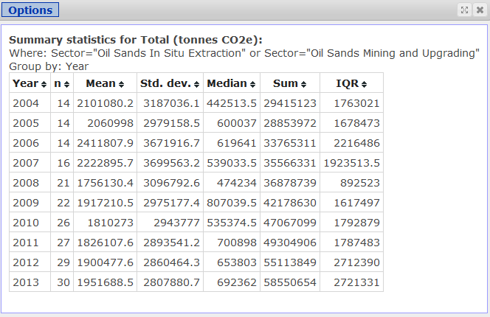

The number of oil sands facilities reporting their emissions increased from 14 in 2004 to 30 in 2013. The average CO2e emissions were about 2 Mt with the medians much lower, between 0.44 Mt to 0.81 Mt. The spread in emissions measured by IQR slightly increased in the period.

- Obtain a time plot for the summaries obtained in part (a). Paste the plot into your report. Comment about the change in total CO2e in the Oil Sands sectors over the period.

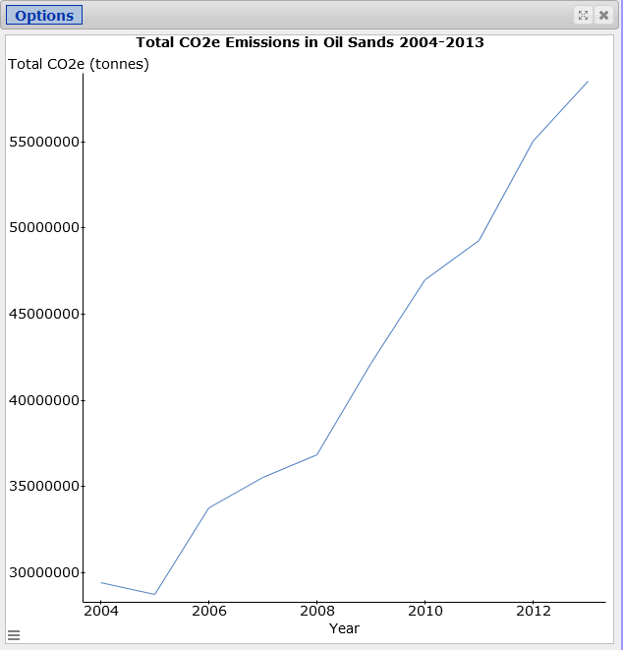

The line chart shows a steep increase in emissions starting 2005. The growth in emissions clearly accelerates after 2008 (larger slope in the period 2008-2013). The growth slows down in 2010-2011.

- Obtain a new variable “Alberta minus Oils Sands” which is the difference of “Total CO2e for all facilities with emissions 100 kt or more” obtained in part (a) and the emissions of the combined Oil Sands categories obtained in part (b). Use “Store in data table” option. Paste the summaries into your report.

Comment about the change in total CO2e emissions for all Alberta facilities without Oil Sands facilities and for Oil Sands facilities in the period 2004- 2013. Then use the summaries to obtain a line chart with total CO2e emissions for all Alberta facilities with 100 kt or more without Oil Sands facilities and Oil Sands emissions only for each year of the period 2004-2013. Paste the chart into your report. Comment briefly.

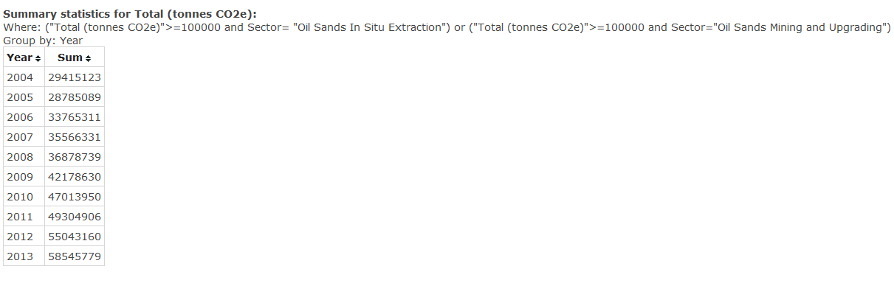

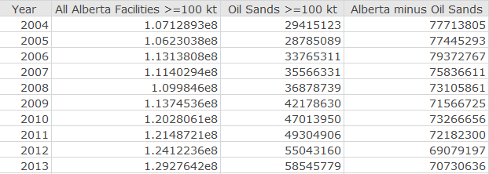

Based on the above output, the facilities in Alberta without Oil Sands reduced their CO2e emissions by approximately 9%. However, the emissions from oil sands have doubled in the same period.

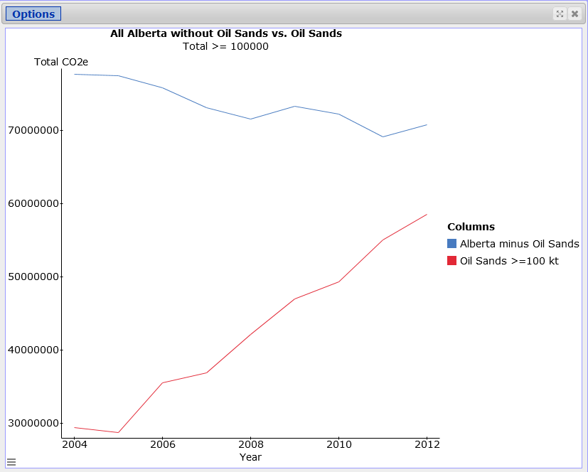
The graph confirms the conclusions reached above. Alberta without Oil Sands CO2e emissions have slightly decreased over the period. However, the emissions from oil sands facilities increased at much higher rate than the rate of decrease of emissions from the remaining Alberta facilities. As a consequence, the total emissions in Alberta sharply increased in the period.

LAB 1 ASSIGNMENT: MARKING SCHEMA

Proper cover page (includes your name, with the surname capitalized, course section and lab assignment number) and appearance (i.a. lab reports must be typed): 10 marks

Question 1

- Assumptions: 2 marks
Limitations: 2 marks
- Variability in the number of facilities in the inventory : 2 marks
Impact on the conclusions about the data: 2 marks
- Effect of the voluntary submissions: 2 marks
- Effect of change in the threshold value: 2 marks

Question 2

- Total number of facilities: 2 marks
Total emissions: 2 marks
Mean, standard deviation, and maximum value: 3 marks (1 each)
Quartiles: 3 marks (1 each)
- Number of voluntary facilities in 2013: 2 marks
Total emissions of voluntary facilities: 2 marks
- Largest emitter in 2013: 2 marks
Total emissions of the largest emitter in 2013: 2 marks
Comparison with 110 lowest emitters: 2 marks
- 95th percentile: 2 marks
The contribution of the top 5% in total CO2e: 2 marks
- Total CO2e emissions for each of the 16 sectors in 2013: 4 marks
Sector with the largest emissions in 2013: 2 marks
Share of the sector with the largest emissions: 2 marks
Pie chart for total CO2e emissions for 16 sectors: 4 marks
Comments: 2 marks
- Total emissions for each gas type: 2 marks
Pie chart for the contribution of each gas in total emissions: 4 marks
Comments: 2 marks
- Properly formatted frequency histogram of total CO2e emissions in 2013: 4 marks
Shape: 2 marks
Conclusions: 2 marks

Question 3

- Total emissions for facilities 100 kt or more: 2 marks
Percentage increase in total emissions: 2 marks
- Time plot: 4 marks
Comments: 2 marks
- Side-by-side boxplot of Total CO2e by Year (proper format): 4 marks
Comments about the centres, spreads and shapes of the 10 distributions: 4 marks
Largest emitters: 2 marks
Progress in reducing emissions by the largest emitter over the period: 2 marks
- Comparison: 3 marks
Information derived from one plot but not the other: 3 marks

Question 4

- Summary statistics: 4 marks
Comments about change in total emissions for Oil Sands: 2 marks
- Time plot: 4 marks
Comments: 2 marks
- Summaries: 4 marks
Comments: 3 marks
Line chart: 4 marks
Line chart interpretation: 3 marks

TOTAL= 130

Henryk Kolacz
University of Alberta
June 27, 2017

